**DAILY ONLINE ACTIVITIES SUMMARY**

|  |  |  |  |  |  |  |  |  |
| --- | --- | --- | --- | --- | --- | --- | --- | --- |
| **Date:** | **08/06/2020** | | | | | **Name:** | **Anjali Manohar Prabhu** | |
| **Sem & Sec** | **4th Sem Section - ‘A’** | | | | | **USN:** | **4AL18CS007** | |
| **Online Test Summary** | | | | | | | | |
| **Subject** | | **Complex analysis, probability and statistical method** | | | | | | |
| **Max. Marks** | | **30** | | **Score** | | | **22** | |
| **Certification Course Summary** | | | | | | | | |
| **Course** | **Cloud Foundation and introduction to ethical hacking** | | | | | | | |
| **Certificate Provider** | | | 1. **Great Learning Academy** | | **Duration** | | | **5.0hrs** |
| **Coding Challenges** | | | | | | | | |
| **Problem Statement:**   1. Write a C Program to Generate All the Set Partitions of n Numbers Beginning from 1 and so on 2. Write a C++ Program to swap two numbers using friend as a bridge concept | | | | | | | | |
| **Status: executed** | | | | | | | | |
| **Uploaded the report in Github** | | | | | **YES** | | | |
| **If yes Repository name** | | | | | [**https://github.com/vinisharen/lockdown-coding**](https://github.com/vinisharen/lockdown-coding) | | | |
| **Uploaded the report in slack** | | | | | **YES** | | | |

Online Test Details: MATH test was conducted as per the given timings, that is from 9:30 am to 10:10 am and portion for the test was ”MODULE 2”. There were 15 questions in total and the time limit for the test was 40 min. each question consist if 2 mark and the marks I scored was 22/30

**SNAPSHOT:**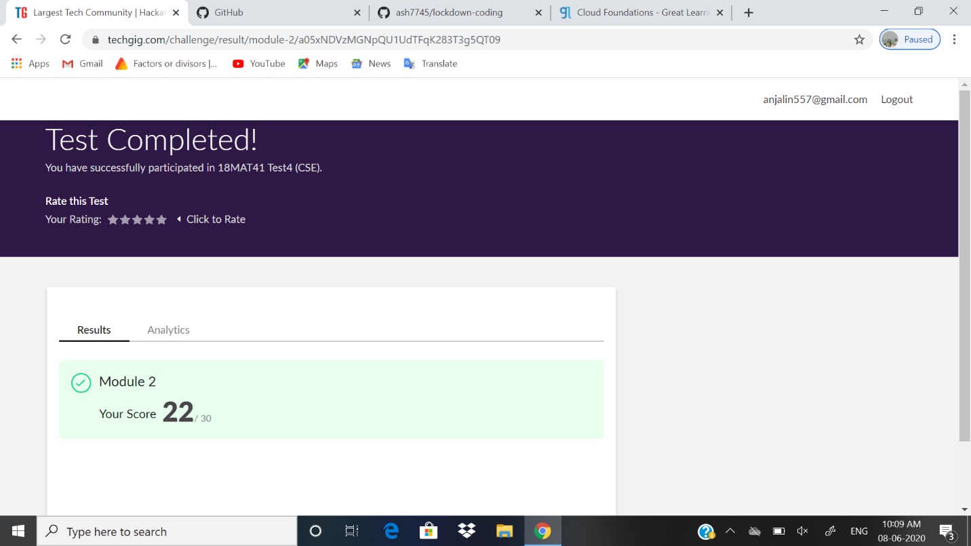

Certification Course Details: I have successfully completed two certification course on “GREAT LEARNING” website

1. **INTRODUCION TO ETHICAL HACKING**
2. **CLOUD FOUNDATION**

And I have also been provided the certificates for completing the following course and also attempting the quiz.

Given below are the snapshot of the certificate of the course that I have completed successfully.

**SNAPSHOT:** This is the certificate of mine for completing “**CLOUD FOUNDATION”** course.

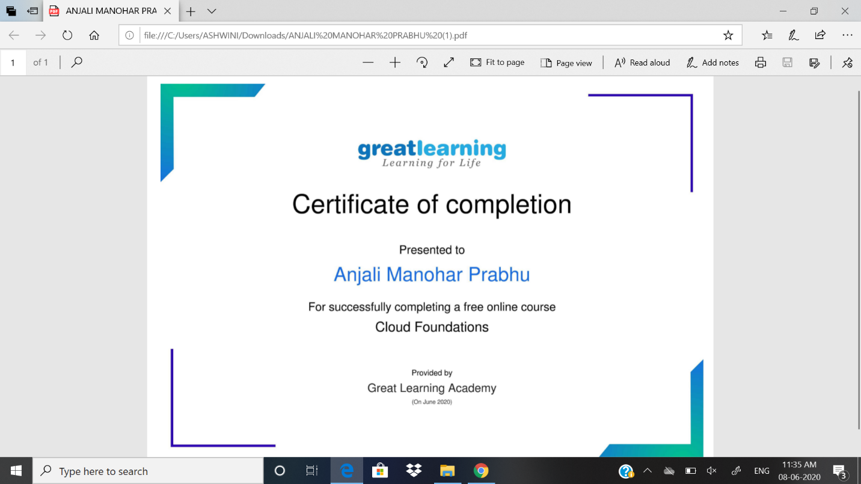

**SNAPSHOT:** This is the certificate of mine for completing “**INTRODUCTION TO ETHICAL HACKING”** course

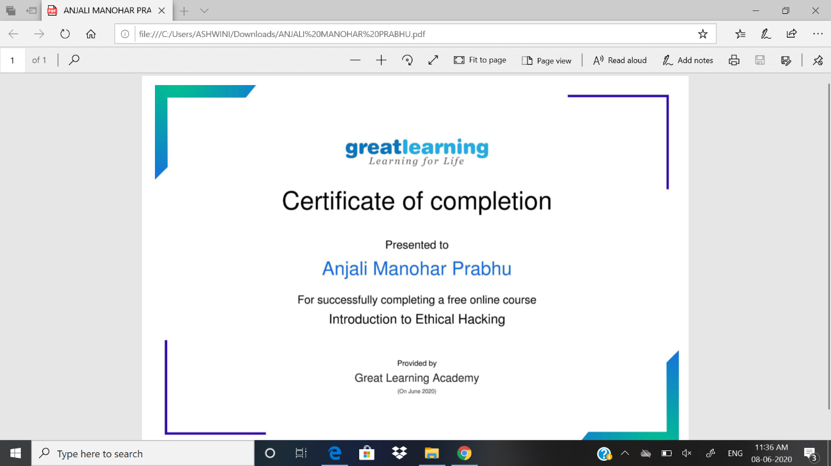

ONLINE CODING DETAILS:

1. PROBLEM 1:Write a C Program to Generate All the Set Partitions of n Numbers Beginning from 1 and so on

SNAPSHOT:

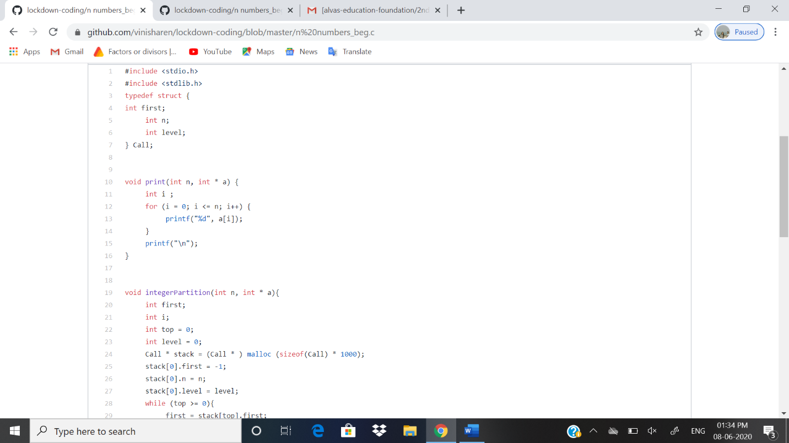

1. PROBLEM 2: Write a C++ Program to swap two numbers using friend as a bridge concept

SNAPSHOT: